10.26: a)

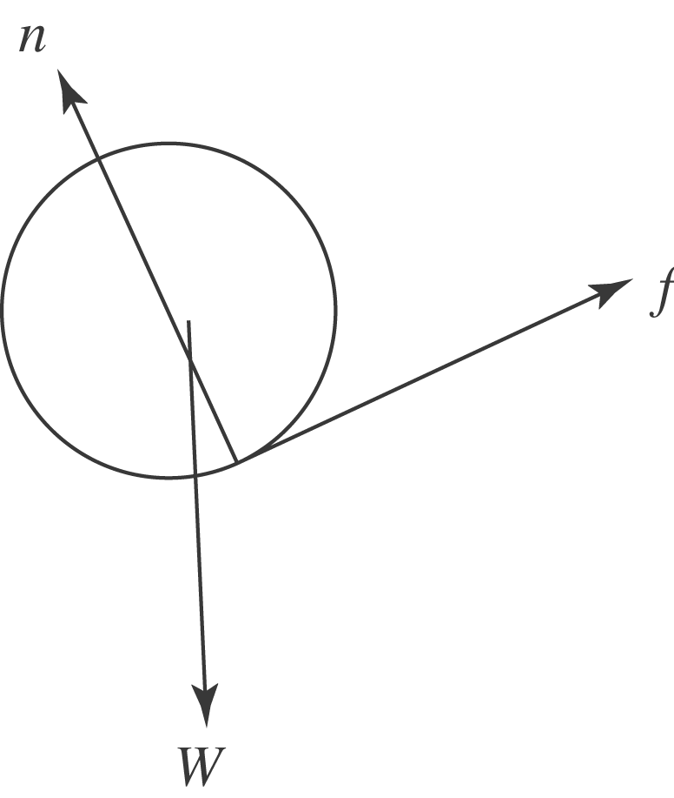
The angular speed of the ball must decrease, and so the torque is provided by a friction force that acts up the hill.

b) The friction force results in an angular acceleration, related by 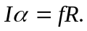The equation of motion is 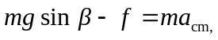 and the acceleration and angular acceleration are related by 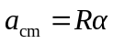 (note that positive acceleration is taken to be down the incline, and relation between 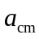 and is correct for a friction force directed uphill). Combining,
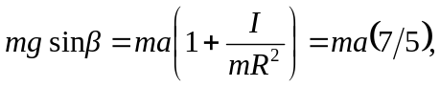
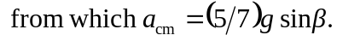 c) From either of the above relations between if f and 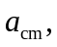
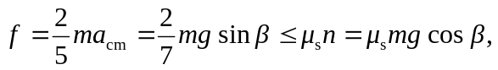
from which 